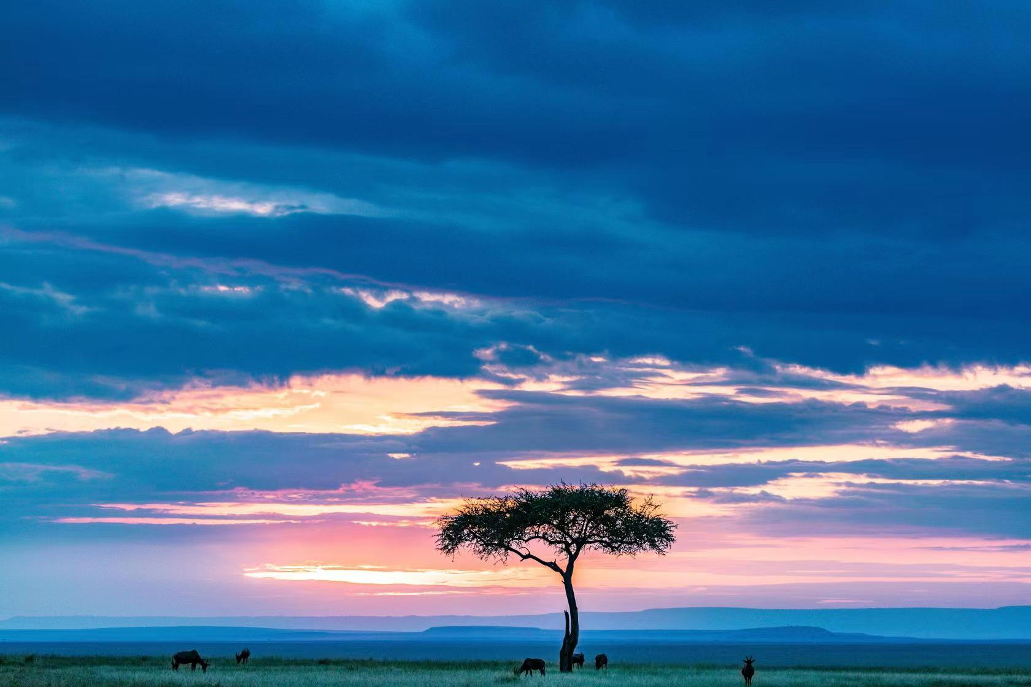

**Alternate Ways to Manage the Masai Mara**

**To Kenyan Tourism and Wildlife Committee:**

We are amateur wildlife enthusiasts. Recently, we learned that the Kenyan parliament passed the Wildlife Conservation and Management Act in 2013, aimed at achieving more equitable sharing of resources and facilitating the adoption of community-based management approaches. While these bills can protect wildlife and other natural resources, they may also have some negative impacts on the local community. Therefore, we collected as much data as possible about the Masai Mara, re-zoned the area, and proposed new policies.

***⦁ New Policies and Management Strategies***

Based on the climate, agricultural land use types, city distributions, and wildlife migration routes, we divide the Masai Mara into three regions (as shown in Figure 1): National Reserve, Pastoral Region, and Cultivated Region. We propose different policies to three regions respectively.

***In National Reserve***：

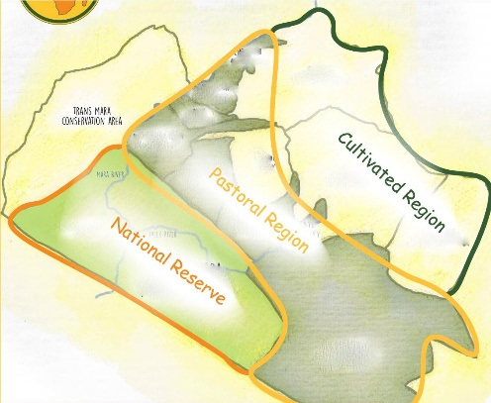

***Figure 1: Maasai Mara Division Area***

1. Prohibition on hunting. It is arguably the most effective way to protect wildlife.

2. Designing fixed tour routes while enhancing infrastructure and security measures along the way. The proposed policies aim to protect the safety of visitors, minimize the negative impact of human-animal interactions, and preserve the ecological environment of the reserve. By achieving these goals, the policies can attract more tourists, foster tourism development, and improve the income of the surrounding residents.

3. Establish a buffer zone at the junction of a National Reserve and Pastoral Region during wildlife migration. It reduces conflicts between people and wildlife, and protects the lives and property of both animals and residents

4. Protect wildlife by guiding and repelling animals on the migration route in before the annual wildlife migration

***In Pastoral Region：***

5. Installing an electrified power grid in the boundary of Pastoral Region, which can cause injury or even death to wild carnivore if they try to intrude. It reduces the hunting of livestock, thus protecting the interests of the local population. It also reduces conflicts between livestock and herbivores, protects herbivores, and prevents vegetation from being eaten up by livestock.

6. Establish a management organization to guide wild herbivores away, while establishing a buffer zone between National Reserve and Pastoral Region, and planting high-quality forage at the boundary for wild herbivores.

7. Expanding the buffer zone during migration is beneficial for both animals and local residents as it allows animals to move freely without causing harm to the residents' interests. Since animals can migrate through the buffer zone, residents can continue to live and work in the surrounding areas without being significantly affected by the movement of wildlife.

***In Cultivated Region:***

8. Arranging patrols near city town to guide wildlife away from human settlements. It is an effective measure to protect the safety of local residents and their property, and to reduce the economic losses caused by animal-human interactions. By guiding wildlife away from human settlements, the risk of dangerous or destructive encounters between animals and humans can be minimized.

9. Maintain healthy grasslands and vegetation in the area that away from city town to reduce wildlife populations close to residential areas.

***⦁ Program Feasibility Analysis***

To validate the feasibility and effectiveness of our proposed strategies, we also develop a simple ecosystem simulation model of the Masai Mara. The model takes factors like interspecific competition, rainfall, inter-ethnic migration, and “big migration” into account. If the policies are strictly followed, our simulation suggests that the ecosystem and economy of the area would be improved a lot after 5 years. Specifically, the grass cover of the Masai Mara is estimated to expand by around 57.27%, and the populations of wild herbivores and carnivores are expected to increase by 74.85% and 64.08% respectively. Moreover, the surrounding economy is predicted to grow by approximately 47.2%.

To examine the applicability of our policy, we replicate the same experiment in another area. We calculate various parameters of this area based on its historical data, and apply our proposed policy, which yield similar results.

Based on these, we believe that the strategies proposed can serve as a useful reference for the management of the Masai Mara Reserve. By taking into account the ecological, economic, and social factors, and implementing policies that balance the needs of wildlife and local communities, it is possible to achieve a sustainable and mutually beneficial relationship between humans and nature in the area.

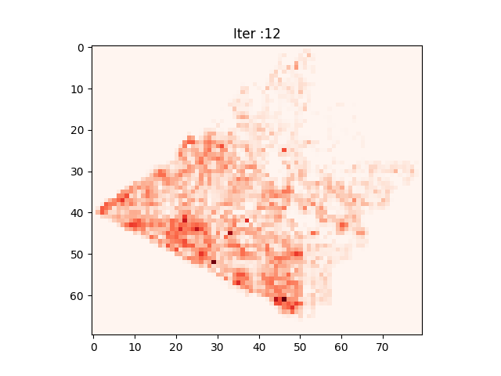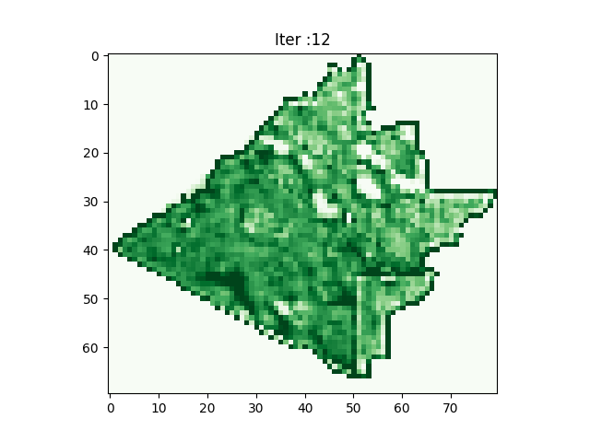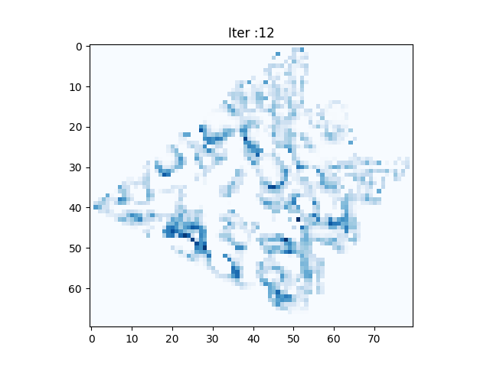

***Figure 2: The Distribution of Grass, Herbivore, and Carnivore During Simulation***

***(a) Grass Percentage Cover***

***(b) Herbivore Biomass Density***

***(c) Carnivore Biomass Density***